**What stats are there on Brave browser adoption? Is it successful?**

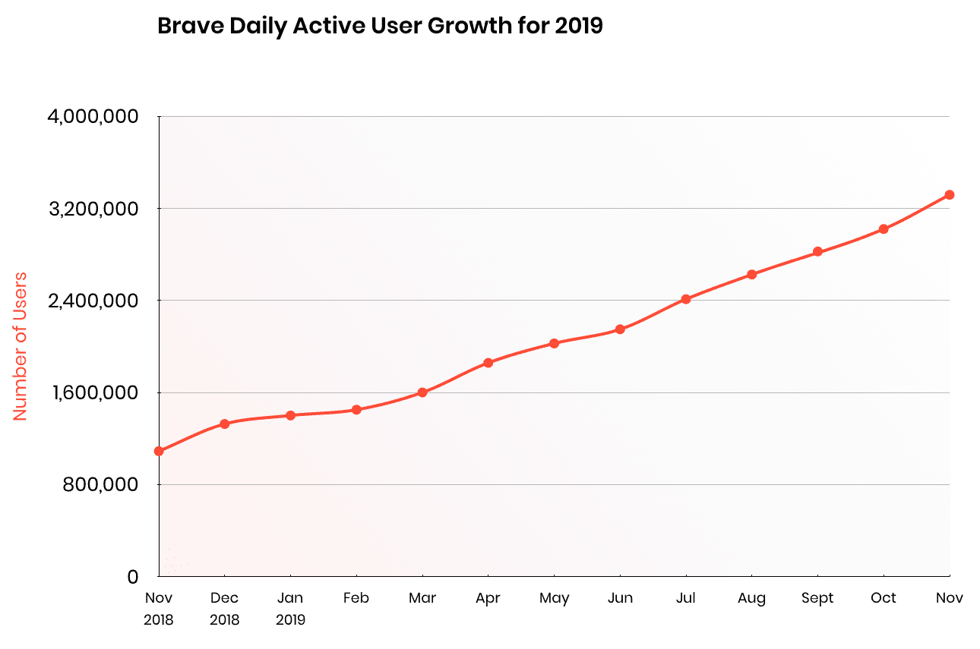Brave’s daily active users has almost tripled in 2019, from 1.2 million to 3.3 million while the monthly active users doubled from 5.5 million to 10.4 million. In March 2020, Brave has experienced vigorous user growth with the addition of 1 million new active users in March 2020, driven by the increasing web usership due to Corona pandemic. That number brings the browser’s monthly active users to 13.5 million and daily active users to 4.3 million, as per Brave CEO’s tweet on 3 April 2020. With the new addition of features like Brave Swag Store, integration of Binance widget into the browser, partner with TAP Network, it is becoming more attracting for privacy-orientated users and expecting to grow exponentially in 2020.

**How is it successful? How does it target its user base?**

* Brave is open source and is built on top of two other open source projects: The Chromium project and the Blink rendering engine, which lets Brave’s team focus on building the powerful features rather than the core web-browsing experience
* Brave also blocks third party advertising, trackers, and other material which takes extra time and data to download, occupies space in memory, and needs more CPU time and power to process, hence, it’s considerably faster than other browsers
* Because of the setup above, Brave uses about half the memory and power as well as a third of data, saving seconds of time and megabytes of data for every page load
* This is especially important for the growing mobile users in under-developed countries, where Brave realizes 30% - 50% bandwidth and battery savings, making both the user’s data plan, and their battery, last longer

**Why do people like it?**

* Brave Rewards - Users can earn 70% of the ad revenue in the format of Basic Attention Tokens (BAT) every time they view privacy-respecting ads through Brave. BAT can be automatically distributing to web content creators based on how much time the user spent on sites. Or, the user can choose to tip sites directly, and even offer a fixed monthly tip amount.
* On default, Brave block phishing, malware, malvertising, and plugins, which have proven to be a security risk. So, the user can browse the internet at ease.
* This leads to better web browsing experience as Brave loads pages three times as fast out of the box with nothing to install, learn or manage.
* Also, Brave’s servers neither see nor store the users’ browsing data. So, it stays private, on the devices, until the users delete it. This means that the user data won’t be sold to third party.
* Brave browser supports most of the Chrome extensions in the chrome web store, because of its Chromium base